**Event Study Results**

As instructed, we used the Eventus platform on WRDS to run event studies for SPAC mergers, regular mergers, and the combined sample. The CRSP Value-Weighted Index was used as the benchmark, and we selected six event windows: (0,0), (0,+1), (0,+2), (0,+3), (-1,0), and (+1,+10). The output below presents the cumulative abnormal returns (CARs) and associated test statistics.

**SPAC MERGER**

|  |  |  |  |  |  |
| --- | --- | --- | --- | --- | --- |
| **Event Window** | **N** | **Mean Cumulative Abnormal Return** | **CSectErr t** | **StdCSect Z** | **Generalized Sign Z** |
| (0,0) | 137 | 21.44% | 6.654*** | 7.200*** | 7.018*** |
| (0,+1) | 137 | 24.68% | 7.890*** | 8.448*** | 8.728*** |
| (0,+2) | 137 | 24.77% | 8.067*** | 8.515*** | 9.240*** |
| (0,+3) | 137 | 24.86% | 7.976*** | 8.443*** | 8.728*** |
| (−1,0) | 137 | 22.49% | 6.888*** | 7.498*** | 6.506*** |
| (+1,+10) | 136 | 4.10% | 3.746*** | 3.281*** | 1.467* |

**REGULAR MERGER**

|  |  |  |  |  |  |
| --- | --- | --- | --- | --- | --- |
| **Event Window** | **N** | **Mean Cumulative Abnormal Return** | **CSectErr t** | **StdCSect Z** | **Generalized Sign Z** |
| (0,0) | 134 | 15.43% | 5.772*** | 7.565*** | 6.426*** |
| (0,+1) | 134 | 16.49% | 6.179*** | 8.197*** | 7.290*** |
| (0,+2) | 134 | 16.55% | 6.254*** | 8.251*** | 7.636*** |
| (0,+3) | 134 | 16.68% | 6.314*** | 8.274*** | 7.982*** |
| (−1,0) | 134 | 15.76% | 5.744*** | 7.571*** | 6.945*** |
| (+1,+10) | 133 | 1.52% | 2.241* | 2.193* | −0.229 |

**COMBINED SPAC&REGULAR MERGER**

|  |  |  |  |  |  |
| --- | --- | --- | --- | --- | --- |
| **Event Window** | **N** | **Mean Cumulative Abnormal Return** | **CSectErr t** | **StdCSect Z** | **Generalized Sign Z** |
| (0,0) | 271 | 18.47% | 8.786*** | 10.130*** | 9.509*** |
| (0,+1) | 271 | 20.63% | 9.962*** | 11.453*** | 11.332*** |
| (0,+2) | 271 | 20.71% | 10.141*** | 11.536*** | 11.939*** |
| (0,+3) | 271 | 20.81% | 10.114*** | 11.474*** | 11.818*** |
| (−1,0) | 271 | 19.16% | 8.944*** | 10.388*** | 9.509*** |
| (+1,+10) | 269 | 2.82% | 4.341*** | 3.907*** | 0.882 |

**SPAC Merger Distribution & T-Test Results**

As instructed, we extracted the announcement year using Stata and created a frequency distribution of SPAC mergers over time. We also conducted t-tests comparing CARs for SPAC and non-SPAC deals.

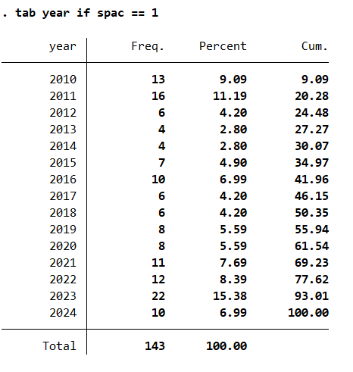

**T-Test Summary**

Three t-tests were conducted on CAR_Window_1 to CAR_Window_3:

* **CAR_Window_1**: p = 0.153 (not significant)
* **CAR_Window_2**: p = 0.048 (significant at 5%)
* **CAR_Window_3**: p = 0.044 (significant at 5%)

The results suggest that SPAC mergers generally experience higher short-term abnormal returns than traditional mergers, particularly in longer windows.

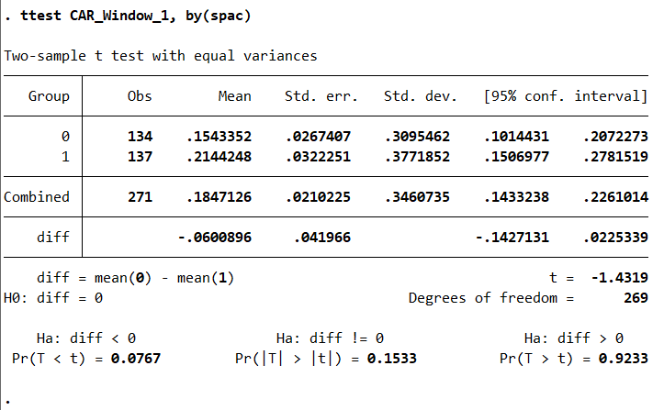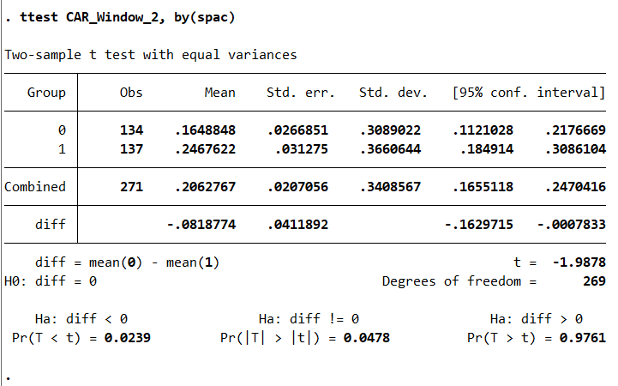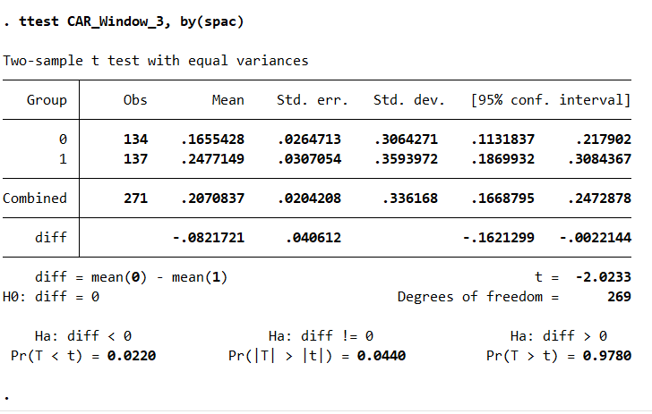

**Section 3: Regression Analysis**

We followed the regression framework as mentioned. Using the final matched sample, we first regressed CARs on a SPAC dummy variable, controlling for TASS, DEAL_VALUE, and year fixed effects. A second model included profitability and market-to-book as robustness controls.

**Key Takeaways:**

* SPAC mergers show **positive CARs**, especially in (0,+1) and (0,+2) windows.
* **DEAL_VALUE** is negatively associated with CARs in most regressions.
* **Profitability**, **market-to-book**, and **TASS** were not statistically significant.

All regressions included year fixed effects to control for merger wave effects.

